

School of Computer Science and Engineering

Program Name: Sec:
Course Code: Course Name:

Course Exit Survey Analysis

Course Outcomes | Strongly disagree | Disagree | Neutral | Agree | Strongly Agree
CO1 | 3 | 3 | 2 | 3 | 20
CO2 | 3 | 3 | 2 | 3 | 20
CO3 | 3 | 3 | 2 | 3 | 20
CO4 | 3 | 3 | 2 | 3 | 20
CO5 | 3 | 3 | 2 | 3 | 20

Total Number of Students in the Course:50
Total Number of Students participated in Survey:31

PI CHARTS for CO1-CO5
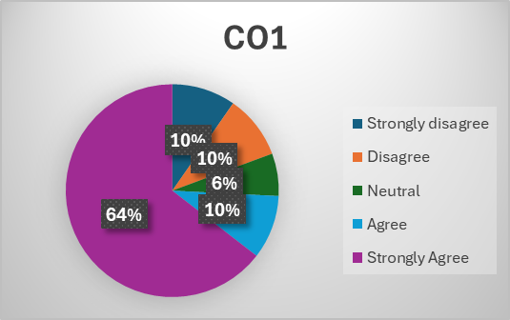

Collective Remarks about text book
About Difficult topics in the Course
About outdated topics in the Course
About the topics to included in the Course

Signature of Course Lead with Date

